Copyright for test papers and marking guides remains with *West Australian Test Papers.*

The papers may only be reproduced within the purchasing school according to the advertised Conditions of Sale.

Test papers should be withdrawn after use and stored securely in the school until Friday 6th December 2013.



## PHYSICS

## YEAR 11

## 2A/2B

**2013**

Name: _______________________________________________________

Teacher: ___________________________________________________

# *TIME ALLOWED FOR THIS PAPER*

## Reading time before commencing work: Ten minutes

Working time for the paper: Three hours

# *MATERIALS REQUIRED/RECOMMENDED FOR THIS PAPER*

**To be provided by the supervisor:**

* This Question/Answer Booklet; Formula and Constants sheet

**To be provided by the candidate:**

* Standard items: pens, pencils, eraser or correction fluid, ruler, highlighter.
* Special items: Calculators satisfying the conditions set by the Curriculum Council for this subject.

# *IMPORTANT NOTE TO CANDIDATES*

No other items may be taken into the examination room. It is **your** responsibility to ensure that you do not have any unauthorised notes or other items of a non-personal nature in the examination room. If you have any unauthorised material with you, hand it to the supervisor **before** reading any further.

All calculations are to be set out in detail. Marks may be awarded for correct equations and clear setting out, even if you cannot complete the calculation. Express **numerical answers** to two (2) or three (3) significant figures and include units where appropriate. Express **estimates** to one (1) or two (2) significant figures, and state any assumptions clearly.

**STRUCTURE OF THE PAPER**

|  |  |  |  |  |  |
| --- | --- | --- | --- | --- | --- |
| Section | No. of  Questions | No. of questions  to be attempted | Suggested working time  (minutes) | Marks available | Proportion of  exam total |
| 1: Short Answers | 16 | ALL | 70 | 64 | 40% |
| 2: Problem Solving | 8 | ALL | 90 | 80 | 50% |
| 3: Comprehension and  Interpretation | 1 | ALL | 20 | 16 | 10% |

Note: Above refers to 3 hour paper.

**INSTRUCTIONS TO CANDIDATES**

Write your answers in the spaces provided beneath each question. The value of each question (out of 160) is shown following each question.

The enclosed Physics: Formulae and Constants Sheet may be removed from the booklet and used as required.

Calculators satisfying conditions set by the School Curriculum and Standards Authority may be used to evaluate numerical answers. The calculator **cannot** be a “**graphics”** calculator.

Answers to questions involving calculations should be evaluated and given in decimal form. Final answers should be given up to three significant figures and include appropriate units where appropriate. Despite an incorrect final result, credit may be obtained for method and working providing these are clearly and legibly set out.

Questions containing specific instructions to **show working** should be answered with a complete, logical, clear sequence of reasoning showing how the final answer was arrived at; correct answers which do not show working will not be awarded full marks.

Questions containing the instruction "**ESTIMATE**" may give insufficient numerical data for their solution. Students should provide appropriate figures to enable an approximate solution to be obtained.

**Section 1: Short Answers**

Marks allocated: 64 marks out of a total of 160 (40%)

Suggested working time: 70 minutes

Attempt ALL questions in this section. Not all questions attract the same marks.

Answers are to be written in the space below or next to each question.

Question 1 (3 marks)

Answer TRUE or FALSE to each of the following.

(a) When 200.0 g of water is heated from 10 oC to 50 oC it has absorbed the same quantity of heat as when it is heated from 60 oC to 90 oC. ____________________________

(b) When 200.0 g of water cools from 50 oC to 10 oC it gives off the same quantity of heat as when it cools from 90 oC to 50 oC. _________________________________

(c) When 200.0 g of water is heated from 20 oC to 60 oC it has absorbed the same quantity of heat as when lead is heated from 20 oC to 60 oC. _____________________________

(specific heat capacity of water is 4.18 x 103 J kg-1 K-1

specific heat capacity of lead is 1.28 x 102 J kg-1 K-1)

(3 marks)

Question 2 (4 marks)

A tray containing 700 mL of water at 20 oC is placed in the freezer compartment of a refrigerator. How much heat must be removed from the water for it to become ice at -4 oC? (4 marks)

Question 3 (2 marks)

Name a safety feature in modern houses that limits the risk of receiving an electric shock and describe how it works. (2 marks)

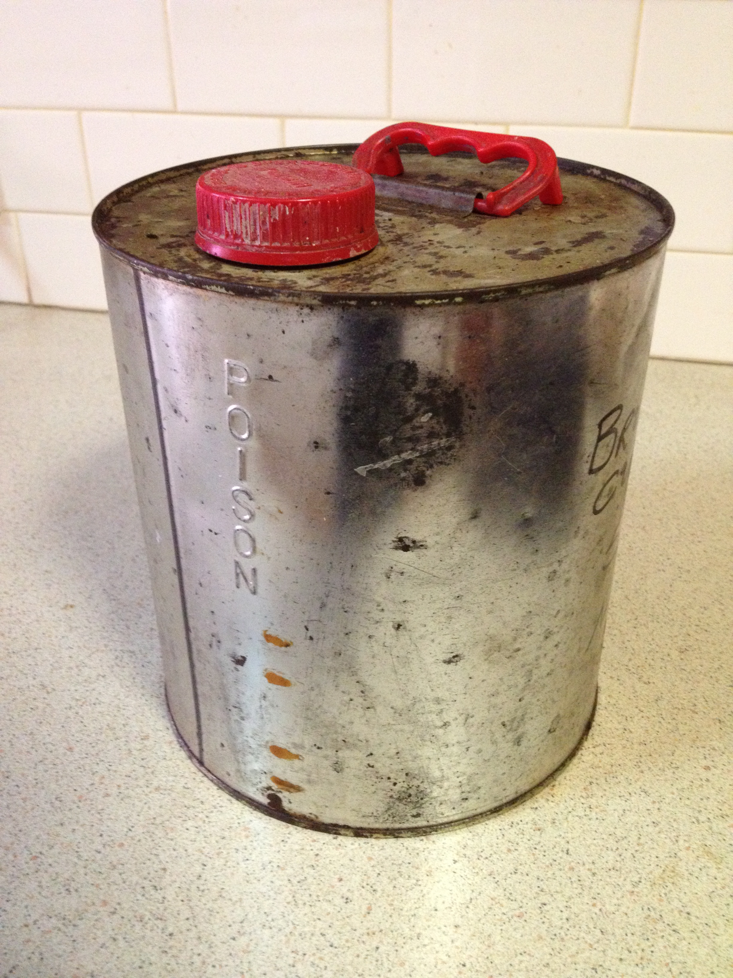

Question 4 (3 marks)

A 4 L sealed can is half full with petrol. In terms of the kinetic theory of matter, describe in detail the behaviour of the molecules of petrol in the can.

Question 5 (3 marks)

The average power applied by an adult’s heart for circulating blood in the body is about 1.50 W.

1. How much work does an adult human heart do in an hour? (1 mark)
2. If this amount of work is used to lift a 50.0 kg object at constant velocity, calculate the theoretical maximum height to which the object can be raised? (2 marks)

Question 6 (4 marks)

A worker on a building site accidently dropped a 4.00 kg hammer and it fell 12.0 m to the ground.

(a) Calculate the speed of the hammer when it hit the ground. (2 marks)

(b) If the impact time of the hammer hitting the ground was 0.300 seconds, calculate the magnitude of the average force exerted on the ground during the impact. (2 marks)

Question 7 (4 marks)

The cathode ray tube in a television set accelerates electrons from rest through a potential difference of 120.0 kV.

1. How much energy, in joules, does each electron gain in being accelerated in this field? (2 marks)
2. If the energy gained by each electron is 98% kinetic, what velocity will the electron have after undergoing this acceleration? (2 marks)

Question 8 (3 marks)

A shop assistant opens a bottle of perfume to demonstrate the fragrance to a customer. Within a few seconds the smell of the perfume can be detected by another shopper who is standing several metres away. Using your understanding of the kinetic molecular theory, explain why the perfume can be detected several metres from the open bottle. (3 marks)

Question 9 (4 marks)

When it is not convenient to connect your iPad to the mains to recharge it, a portable charger can be used. A typical portable charger can deliver 3.0 V with a current of 1.9 A.

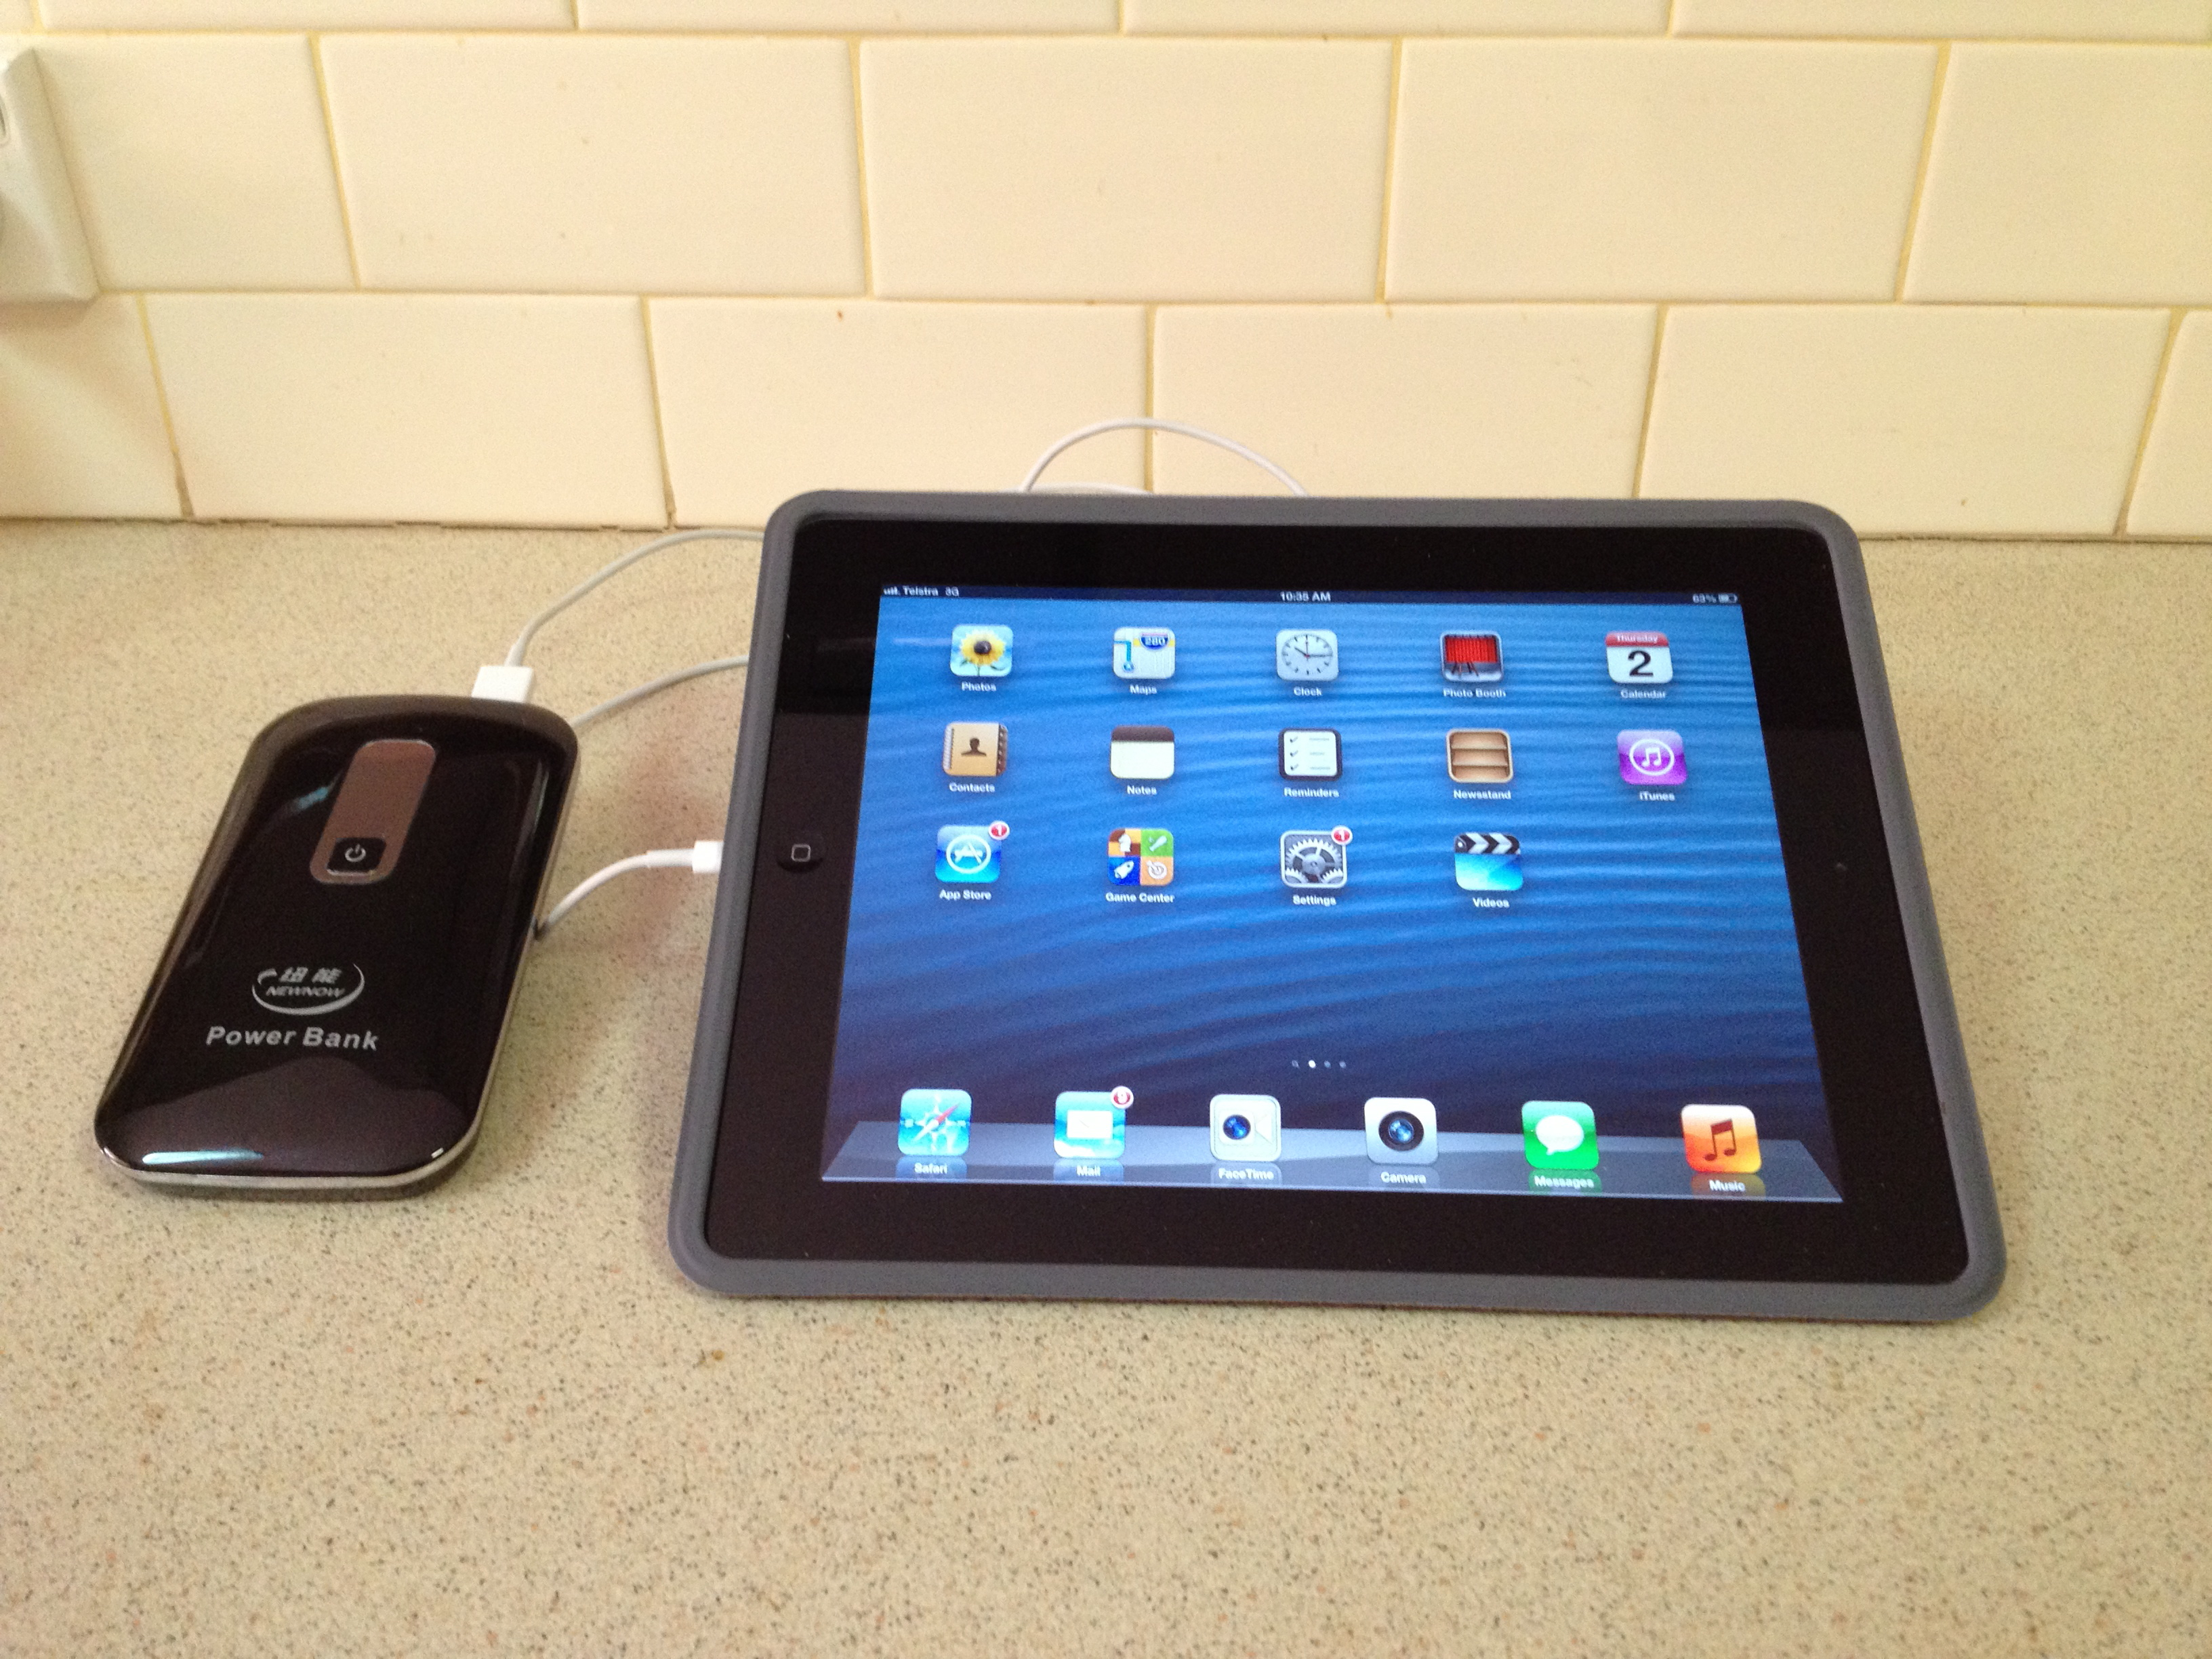

1. If the device is connected to the iPad for 2.5 hours, how much charge flows from the portable charger to the iPad in that time? (2 marks)
2. How much work is done in moving the charge? (2 marks)

Question 10 (3 marks)

A four outlet power board (see photo opposite) used to connect a computer, printer and desk lamp to a single 240 V outlet, is rated for a maximum current of 8.00 A. Why shouldn’t an electric heater, rated at 240 V and 2.50 kW, be plugged into the fourth outlet on the power board? Explain, and support your answer with calculations. (3 marks)

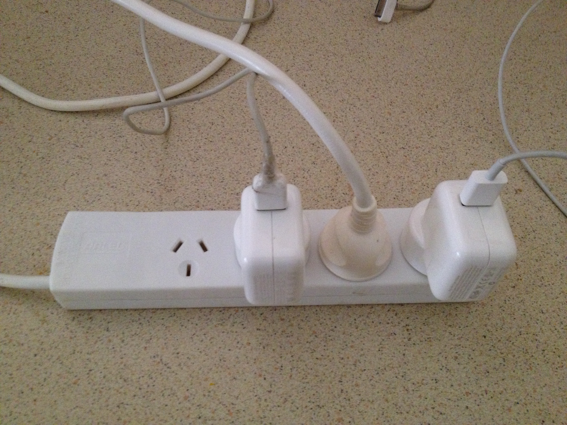

Question 11 (4 marks)

A fully loaded A 380 Airbus having a mass of

5.60 x 105 kg takes off at an angle of 20o

to the runway and is propelled forward by

its four engines.

(a) On the photo opposite draw arrows to

show the forces that are acting on the

aircraft as it takes off. (2 marks)

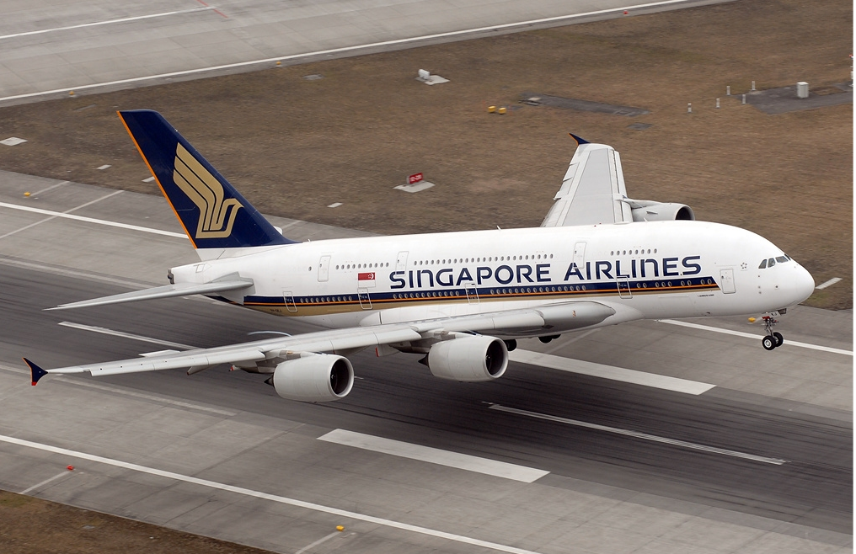

(b) Calculate the minimum vertical force that the engines need to produce to just lift the Airbus

off the runway. (2 marks)

Question 12 (6 marks)

Nuclear fusion is a major source of energy in the Universe. One fusion reaction involves the combination of four protons and two electrons to form a helium nucleus, two neutrinos and six photons. Neutrinos and photons have no mass. The overall equation for this reaction is:

4 1H1 + 2e 🡪 He + 2 + 6

1. Calculate, in joules, the energy released from this process due to the mass defect. (4 marks)
2. Calculate, in MeV, the energy released from this process due to the mass defect. (2 marks)

Question 13 (6 marks)

(a) Complete the following nuclear equations and name the particle / radiation type.

(4 marks)

(i) 1n0 + 235U92 🡪 140Xe54 +94Sr38 + ___________

Name of particle____________________

(ii) 239Np93 🡪 239Pu94 + _______

Name of particle_____________________

(b) Write balanced nuclear equations for the following decays. (2 marks)

1. Iodine -131 by beta negative decay.
2. Radon – 220 by alpha decay

Question 14 (5 marks)

A 161.0 g cricket ball moving at 25.0 m s-1 hit the edge of a stationary bat transferring 18.1 J of energy to the bat.

(a) Calculate the speed of the ball after the collision. (3 marks)

(b) The ‘hot spot’ image of the collision taken at the instant of impact shows that about

4.0 g of bat wood absorbed the 18.1 J of energy and increased the temperature of that portion of the bat. Estimate the temperature increase of that portion of the bat.

(The specific heat capacity of the bat wood is 2.25 x 103 J kg-1 K-1) (2 marks)

Question 15 (4 marks)

(a) A common way of keeping warm in bed during cold nights is to cover ourselves with blankets. Explain briefly how blankets keep us warm by referring to the three (3) methods of heat transfer: conduction, convection and radiation. (3 marks)

(i) Conduction

(ii) Convection

(iii) Radiation

(b) Some people prefer a doona instead of blankets to keep warm. (A doona is an envelope of fabric filled with either feathers or fibre). Describe in terms of heat transfer the major advantage of a doona compared to blankets. (1 mark)

Question 16 (6 marks)

A 50.0 g ball is hit vertically into the air with a tennis racquet. The ball travels 15.5 m before reaching its maximum height and returns to the exact position from which it was hit.

(For the following questions assume negligible air resistance).

1. With what speed did the ball leave the racquet? (2 marks)
2. What was the ball’s speed at its maximum height? (1 mark)
3. How long did the ball take to reach its maximum height? (2 marks)
4. Calculate the speed of the ball when it had travelled 31 m. (1 mark)

**END OF SECTION 1**

**Section 2: Problem Solving**

Marks allotted: 80 marks out of a total of 160 (50%)

This section contains 8 questions. Suggested working time 90 minutes

Answer the questions in the spaces provided.

Question 17 (12 marks)

The diagram opposite represents an electric circuit that has been set up to demonstrate various electrical concepts. The globes are identical in every way and each has a resistance of 20.0  and a power rating of 2.0 W. The power supply is set on 12.0 V.

The circle “X” represents a meter.



(a) Calculate the total resistance in the circuit.

(Exclude the internal resistance of the meter and the power supply). (4 marks)

1. What is the reading on this meter labelled X? (include units). (3 marks)

(c) Is the current flowing through globe 1 equal to the current flowing through globe 2?

Support your answer with appropriate calculations. (3 marks)

(d) Is globe 1 operating at its maximum power output? Support your answer with an appropriate calculation. (2 marks)

Question 18 (12 marks)

In a 50.0 km long distance race involving an able -bodied runner and a wheelchair athlete, the able-bodied runner maintained an average speed of 17.0 km h-1 for the race. The wheelchair athlete set off 30.0 minutes after the able-bodied runner and travelled at an average of

21.0 km h-1 for the race.

(a) Calculate how long it took for the able-bodied runner to finish the race. (2 marks)

(b) Calculate how long it took for the wheelchair athlete to finish the race. (2 marks)

(c) Who won the race? Support your answer with calculations and clear reasoning. (2 marks)

(d) By how many minutes did the winner beat the loser? (2 marks)

(e) When the winner crossed the finish line how much further did the loser have to travel before they finished? (2 marks)

(f) What average speed would the loser of the race have had to maintain, just to finish at the same time (that is, draw the race), as the winner? (2 marks)

Question 19 (12 marks)

When a uranium-235 nucleus absorbs a neutron, many fission products are possible. One such reaction in a nuclear power plant results in the formation of lanthanum-148 (La), bromine-85 (Br) and neutrons.

(a) Write an equation for this reaction. (3 marks).

(b) How many neutrons are produced in this reaction? (1 mark)

(c) The waste removed from the power plant had a measured activity of 128.0 Bq above the background count of 2.00 Bq. What is meant by the term ‘background count’?

(2 marks)

(d) Give an example of a source of background radiation. (1 mark)

(e) The radiation monitor worn by an 85.0 kg worker at the power plant indicated he had absorbed 24.0 J of energy when exposed to the nuclear waste. Calculate the dose he had absorbed. (2 marks)

(f) Determine the dose equivalent for the worker, assuming 90% of the radiation was from gamma radiation and 10% from alpha. (3 marks)

Question 20 (9 marks)

In an experiment to demonstrate how efficiently electrical energy is transformed into heat energy, a student set up an electrical circuit containing a nichrome wire heating coil immersed in a glass beaker of water. The circuit was switched on and the time to bring the water to its boiling point was recorded.

Data collected from the experiment.

Volume of water = 100.0 g

Initial temperature of the water = 21.0 oC

Time for water to reach boiling point = 20 min

Steady reading on the voltmeter = 12.0 V

Steady reading on the ammeter = 2.50 A



(a) Calculate the quantity of electrical energy produced by the circuit. (2 marks)

(b) Calculate the quantity of heat energy absorbed by the water. (2 marks)

(c) Calculate the efficiency of the system if the aim is to conserve energy between the heating coil and the water. (2 marks)

(d) Explain why the efficiency is not 100%. (2 marks)

(e) Suggest one improvement that could be made to increase the efficiency of the system. (1 mark)

Question 21 (11 marks)

(a) Polonium (214Po84) is a radioactive isotope that undergoes decay via a series of steps. Each step involves the release of ionizing radiation.

Step 1 Po – 214 to Pb - 210

Step 2 Pb – 210 to Bi – 210

Step 3 Bi – 210 to Po – 210

Step 4 Po – 210 to Pb – 206

For each step write a nuclear equation and name the type of radiation released.

Step 1_________________________________________Type of radiation________ (2 marks)

Step 2_________________________________________Type of radiation________ (2 marks)

Step 3_________________________________________Type of radiation ________ (2 marks)

Step 4_________________________________________Type of radiation ________

(2 marks)

(b) In an experiment to study radioactive decay, a 100.0 g sample of Po-214 is placed in a sealed container to decay. After a suitable length of time the polonium atoms have become mostly Pb-206 atoms. The container is regularly analysed during this time.

(i) Describe how the number of decays per second would change during this time. (1 mark)

(ii) In terms of nuclear particles how are Pb-210 and Pb-206 different? (1 mark)

(iii) Why are there no more steps in this decay chain after the formation of Pb–206? (1 mark)

Question 22 (9 marks)

A Formula One racing car accelerates uniformly from rest to a speed of 250.0 km h-1 in 4.50 s and then travels at that speed for the next 3.00 s.

(a) On the graph grid below, represent the speed versus time of the car. Label the axes and include scales and units for speed and time. (2 marks)



(b) The acceleration of the car can be determined by using the graph. DESCRIBE how you could use the graph to determine the acceleration. (2 marks)

(c) Use the graph in the way you described in (b) above, to determine the acceleration, in

m s-2 of the car during the first 4.5 s. (2 marks)

(d) Calculate the distance the car travelled in 7.5 s. (3 marks)

Question 23 (8 marks)

Some students conducted an experiment to determine the **latent** **heat of fusion of ice**.

They followed the method below:

* Warm water was placed into a copper calorimeter and the temperature recorded.
* An ice cube at 0.00 °C was dried with a paper towel.
* The ice cube was placed in the warm water in the calorimeter and the final temperature was recorded when the melted ice, the water and the calorimeter had reached thermal equilibrium.
* Results were recorded in the table below.

Table of results:

|  |  |
| --- | --- |
| **Measurement** | **Data** |
| Mass of copper calorimeter | 73.0 g |
| Mass of calorimeter + warm water | 159 g |
| Mass of calorimeter + warm water + ice | 193 g |
| Mass of warm water |  |
| Mass of ice |  |
| Initial temperature calorimeter + warm water | 41.6 °C |
| Final temperature calorimeter + warm water + melted ice | 9.00 °C |
| Temperature change calorimeter + warm water |  |
| Initial temperature of ice | 0.00 °C |
| Temperature change of melted ice (water) in calorimeter | 9.00 oC |

(a) Complete the table by filling in the blanks. (Some of the values have been done for you.)

(2 marks)

(b) Use this data to **calculate** the latent heat of fusion of ice in this experiment. (6 marks)

* + - * *The specific heat capacity of copper is 380 J kg-1 K-1*

Question 24 (7 marks)

(a) Resistors can be either ohmic or non-ohmic. Describe how these two types of resistors differ. (2 marks)

(b) An ohmic resistor labelled 5.0 W is in an electrical circuit where the potential can vary from 1.0 V to 100.0 V.

(i) Calculate the range of current that will flow in it. (2 marks)

(ii) Calculate the energy that will be dissipated in the resistor each second when a current of 5.0 A is flowing through it. (1 mark)

(iii) What factors determine how much power is dissipated in the ohmic resistor? (2 marks)

**END OF SECTION 2**

**Section 3: Comprehension**

(Marks allocated: 16 marks out of 160 (10%). Suggested working time 20 minutes.

This section has one (1) question. You must answer this question. Write your answer in the spaces provided.

When estimating numerical answers, show your working or reasoning clearly. Include appropriate units.

Question 25

Cycling is good for the environment and your health but sometimes you may need a little help. That is the reason there has been an increase in the sale of electric bicycles, particularly to more elderly people. An **electric bicycle**, also known as an **e-bike**, is a [bicycle](http://en.wikipedia.org/wiki/Bicycle) with an integrated [electric motor](http://en.wikipedia.org/wiki/Electric_motor) that can be used for propulsion. There is a great variety of different types of e-bikes available in Australia, from e-bikes that only have a small motor to assist the rider's pedal-power (i.e. [pedelecs](http://en.wikipedia.org/wiki/Pedelec)) to somewhat more powerful e-bikes which tend closer to motor bike style functionality. All however retain the ability to be [pedalled](http://en.wikipedia.org/wiki/Bicycle_pedal) by the rider and are therefore not [electric motorcycles](http://en.wikipedia.org/wiki/Electric_motorcycles). E-bikes use rechargeable batteries and the lighter models can travel up to 25 - 32 km /h, depending on the laws of the country in which they are sold, while high-powered models can often travel a lot faster.

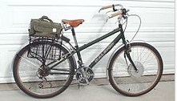

E-bikes typically have a 200 W motor, powered by a 36 V, 10 Ah (amp hour) lithium ion battery pack that can be recharged from 240 V mains supply using a transformer.

The distance they can travel on a fully charged battery depends on whether you use the ‘pedal assist’ function. That means you can extend the range by pedaling at the same time as using the electric motor.

Travelling on a flat, sealed road surface the battery will take you about 60 km without pedaling. If on the other hand you use the pedal assist function the range can be extended to 100 km. Compared to a carbon frame racing bike at about 7.0 kg, the typical e-bike, at 25 kg is not the lightest option to pedal. However, the mass disadvantage is compensated for by ease of operation.

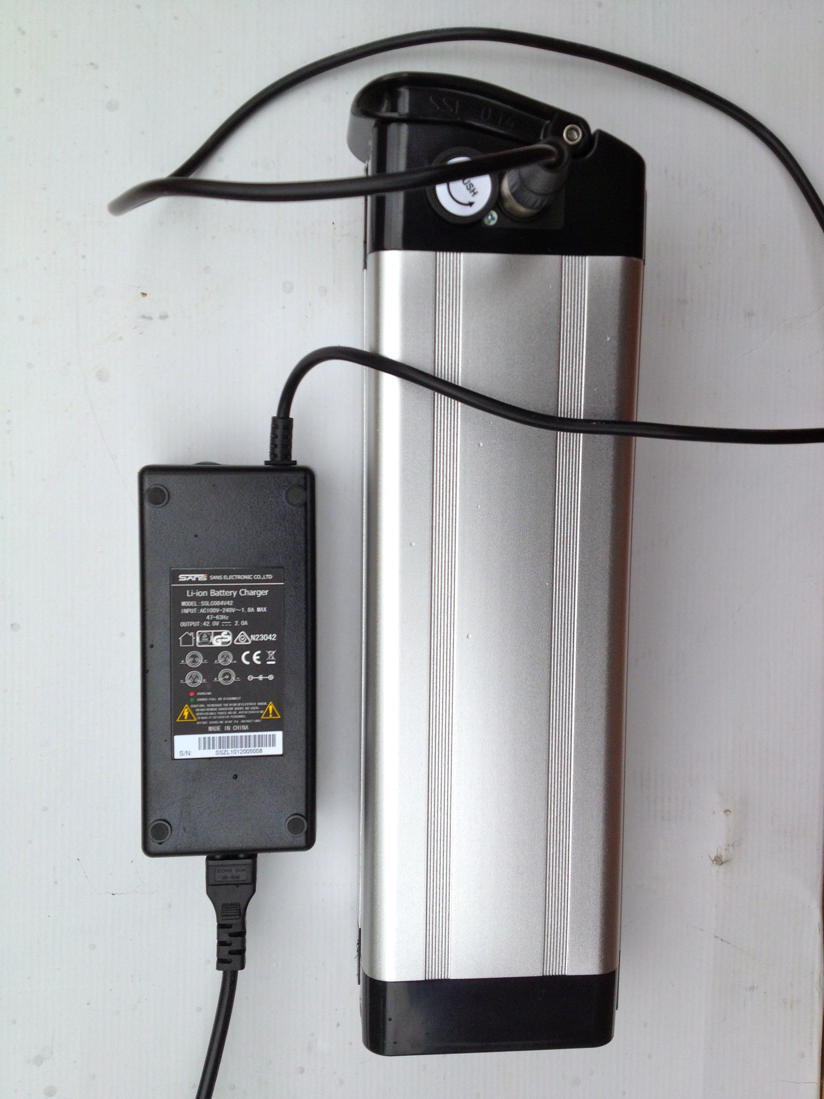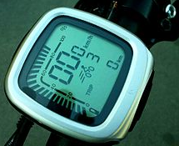

An integrated computer attached to the handlebars conveys information to the rider about distance travelled, speed, battery charge and projected range. Using this data the rider can make decisions about how likely they will be able to reach their destination!!

Questions

(a) In what way are e-bikes ‘good for the environment’? (2 marks)

(b) In what way are e-bikes ‘good for your health’? (2 marks)

(c) If the e-bike’s 200 W electric motor is working at its stated power, calculate the current it would be drawing from the lithium ion battery. (2 marks)

(d) Amp hours (Ah), when applied to batteries, provides an approximate indication of how long a battery is capable of delivering a particular current (A). For instance a battery rated at 10 Ah could deliver 5A for 2 hours when connected to an appliance. If the typical e-bike described in the article, draws 3A on a ride, calculate how long the battery will deliver enough power to propel the bike. (2 marks)

(e) Explain what would happen to the power output of the motor when the rider was using the pedal assist function and how would this change the distance the rider could travel. (2 marks)

(f) If the rider elects not to use the pedal assist function ESTIMATE the amount of work done by an adult rider travelling along a smooth, level cycle path for 3.5 km. (2 marks)

(g) After a ride the cyclist discovers the battery is completely discharged. If the battery is connected to a 36 V charger that delivers a steady current of 2.0 A to the battery for

2.0 hours, calculate the quantity of charge that is delivered to the battery.

(2 marks)

(h) Estimate the electrical resistance in the e-bike electrical system when the

200 W motor is being driven by its 10 Ah battery. (2 marks)

**END OF QUESTIONS**